SCHOOL BUS LIVE ETA TRACKER
@CREATIVITY THINK (9483175986/7019689991)

ABSTRACT:
School Bus Live ETA Tracker is a web-based application designed to provide real-time tracking of school buses using simulated GPS data. The system enables parents to monitor bus locations, receive stop-wise Estimated Time of Arrival (ETA), and get delay or cancellation alerts. The platform also includes a dashboard for school administrators to manage buses, drivers, and routes, monitor punctuality, and export route-wise reports. Developed using Django REST Framework, React, LeafletJS, and Redux, the system ensures a smooth user interface, efficient route visualisation, and reliable notification delivery for improved student safety and operational transparency..

INTRODUCTION OF THE PROJECT:
Managing school transportation manually can lead to delays, communication issues, and parent anxiety. With the increasing need for safety and transparency, real-time bus tracking systems have become essential. This project provides a web-based platform that displays live bus locations (from dummy GPS feeds), estimated arrival times, route information, and notifications. Schools and transport vendors can easily supervise the entire fleet through an admin dashboard, while parents can confidently monitor their child’s school commute..

PROJECT OBJECTIVES:

• Provide real-time (simulated) bus location tracking on a map
• Display stop-wise ETA for parents
• Send alerts for delays, route changes, or cancellations
• Offer a dedicated parent dashboard for ride history and daily tracking
• Provide admin dashboard to manage buses, drivers, and routes
• Enable dummy GPS API/cron simulation for realistic tracking
• Log incidents and punctuality metrics for analysis
• Export daily, weekly, or monthly route reports

PROBLEM OF THE STATEMENT:
Traditional school transport systems struggle with communication gaps and lack of real-time visibility. Parents are often unaware of bus delays, route deviations, or arrival times, causing stress and safety concerns. School administrators face difficulty supervising multiple buses and tracking punctuality. This project solves these challenges by implementing a live bus tracking solution using GPS simulation, ETA prediction, and alert notifications, improving safety, trust, and operational efficiency..

MOTIVATION OF THE PROJECT:
• To increase safety and transparency in school transport systems
• To reduce parent anxiety through real-time visibility and alerts
• To streamline bus fleet management for schools and transport vendors
• To automate ETA calculation and reduce waiting times
• To maintain punctuality logs and operational analytics
• To create a scalable solution that works even with dummy GPS feeds

BLOCK DAIGRAM OF PROJECT:

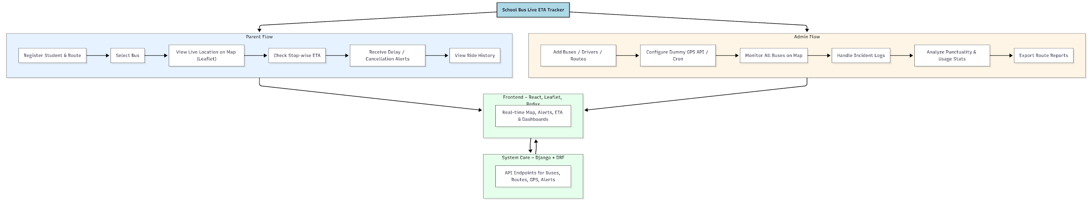

WORKING OF THE PROJECT:
The system works by simulating GPS data for each bus using a periodic cron/API update. Parents register their child and select the respective route. The frontend fetches live bus coordinates and displays them on a map using LeafletJS. The system calculates ETA for each stop based on bus speed and route distance. Any delays or route deviations trigger alerts sent directly to parents. Administrators can monitor the entire fleet in real time, view punctuality reports, manage buses and drivers, and export operational data..

SOFTWARE REQUIREMENT:
- Backend:
  - Python 3.x
  - Django
  - Django REST Framework
  - SQLite/PostgreSQL
- Frontend:
  - Node.js and npm
  - React.js
  - Axios
- Development Tools:
  - Visual Studio Code
  - Postman (for testing APIs)
  - Git/GitHub (for version control)
- Server/Deployment (Optional):
  - Gunicorn, Nginx, or Heroku/AWS for hosting

ADVANTAGES OF THE PROJECT:

• Real-time (simulated) GPS-based bus tracking
• Stop-wise ETA for parents reduces waiting time
• Immediate alerts for delays or cancellations
• Centralized dashboard for route and bus management
• Improved safety and transparency for students
• Accurate punctuality and operations analysis
• Easy to scale and integrate with real GPS later

APPLICATIONS OF THE PROJECT:
• School bus fleet management
• Transport vendor route monitoring
• Parent-child safety monitoring systems
• Real-time location tracking platforms
• Educational institution operations dashboard

REFERENCES:

- Django REST Framework Documentation — Django Software Foundation. Django Documentation. Available: https://docs.djangoproject.com/
- Django REST Framework. DRF Documentation. Available: https://www.django-rest-framework.org/
- React. React Official Documentation. Available: https://reactjs.org/docs/getting-started.html
- Redux. Redux Documentation. Available: https://redux.js.org/introduction/getting-started
- PostgreSQL Global Development Group. PostgreSQL Documentation. Available: https://www.postgresql.org/docs/
- MySQL. MySQL Reference Manual. Available: https://dev.mysql.com/doc/
- Git. Git Documentation. Available: https://git-scm.com/doc
- Node.js. Node.js Documentation. Available: https://nodejs.org/en/docs/
- Axios. Axios Documentation. Available: https://axios-http.com/docs/intro
- Socket.io Documentation – https://socket.io/docs/

